FatTail Media Tree Guidance: Shared Template Project

What’s going away:
- Sunset Ad Units (Article + HP + Section Front):
  - B728
    - Typically Level 4: Leaderboard | Position: BTF
  - A728
    - Only need to remove for sponsorship products
  - GO300
  - MW728 units
  - LA300
  - SPweather tile
- Sunset creative sizes:
  - Ending practice of Master-Companion for most products except for The Crown
  - 3x1, 3x3 --> 1x1 + KVP targeting
  - 1200x300, 980x40, 971x90, 970x415, 970x168, 960x150, 704x300 --> 970x250
  - 150x47 (SP150 div – will only be supported on ATU as LNLogo)
- Sunset Rich Media Units:
  - Sunset SBB (Level 4)
    - Sliding Billboard
    - Pencil
    - Pushdown
  - Sunset Wallpaper (Level 4)
    - Wrap (A728 Block)
    - Wrap
    - Rich Media/Wrap
    - Rich Media | Position: OOP
  - Sunset old Crown products

What’s staying but changing:
- Change targeting for Billboard (Level 4): 950x30, 971x90, 950x30, 970x250, 970x415, 960x150
  - Change to 970x250
- Rich Media: Hero
  - 950x30 --> 970x250
- “ALL” products need to remove KVP targeting: position = atf, btf, or stf
- M-Dot Removal: Remaining CT Community Sites
  - Changing ad unit targeting from .mobile to .com and adding device targeting
- Geo-Targeting (Limit EEA Going Away)
  - For all products that did not have geo targeting/exclusions or postal code targeting/exclusions, default add geo targeting to Country: US

What’s new:
- Add supported Rich Media Units to non-Section Front nodes in the media tree; please make sure that “Rich Media” or “RM” is called out as a position level in the media tree and added to the Traffic Name.
  - Supreme (full width): 88x88
  - Superhero (full width): 88x88 OR 950x30 for old homepage/section fronts
  - Hero (fixed size): 970x250 (wider screens) and 300x250 (mobile)
  - Crown (full width): Master-Companion 99x99 + 1x1 – we need the Flex1 to return a 1x1 so that we apply CSS to hide the unit
  - SuperCrown (full width): Master-Companion 99x99 + 1x1 – we need the Flex1 to return a 1x1 so that we apply CSS to hide the unit
  - Cinema (Widescreen Only): 300x600 ATF
    - Devices: Desktop, Tablet (Optional)
  - Mini Cinema (Cross Platform): 300x250 ATF
  - Flipbook (Widescreen Only): 970x250 ATF
    - Devices: Desktop, Tablet (Optional)
  - Flipbook (Cross Platform): 300x600 and 300x250
  - Countdown Clock: 300x250 ATF
  - Interscroller: 300x250 ATF + page_type2 = article
    - Devices: Mobile/Feature Phone only (Required)
- Add Listicle nodes (per section + ROS) with the following products
  - Billboard 970x250 ATF or Leaderboard 728x90 ATF
  - Mobile Only: Mobile Banner 320x50/300x250 ATF
  - Half Page 300x600 ATF (Desktop/Tablet Only)
  - Rectangle 300x250 ATF (Mobile Only)
  - All supported Flex1 rich media units
  - page_type2 = slideshow list view
- Add supported products to Section Front nodes in the media tree
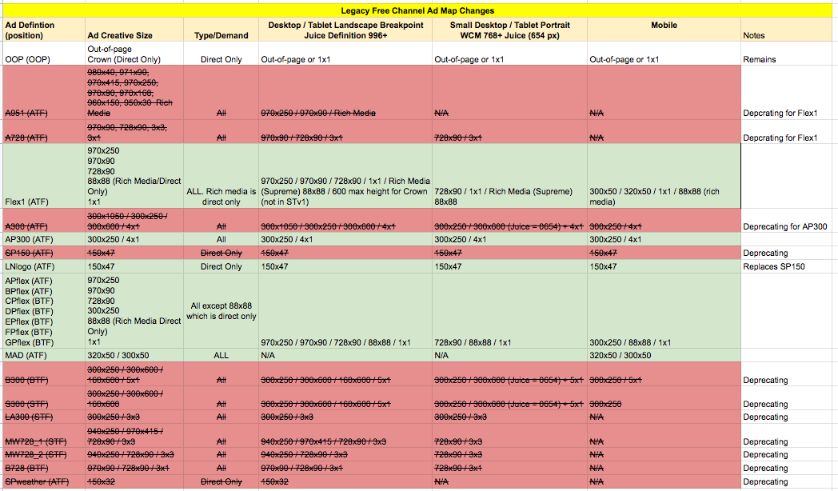
  - Superhero (full width): 88x88 OR 950x30 for old homepage/section fronts
  - Premiere (full width): 728x90 ATF for old homepage/section fronts
  - Supreme (full width): 88x88
  - Superhero (full width): 88x88 OR 950x30 for old homepage/section fronts
  - Hero (fixed size): 970x250 and 300x250
  - Crown: Master-Companion: 99x99 + 1x1 (might change)
  - SuperCrown: Master-Companion: 99x99 + 1x1 (might change)
  - Flipbook (Widescreen Only): 970x250 ATF
  - Flipbook (Cross Platform): 300x600 and 300x250
  - Countdown Clock: 300x250 ATF

Premium Section Front Notes:
- Flex1 is being added to above the masthead – NOTE: This only has a 320x50 and 300x50 size on mobile
- APflex – FPflex remain on page (dependent on content)
- GPflex is being removed from the page
- MAD unit is being added (320x50) – final details pending
- APflex and BPflex will continue to use position = ATF (this is tied to load logic and can’t be changed) – if you want to truly target ATF you will need to target the DIV_ID for Flex1, APflex, and BPflex separately
- AP300 will only be available on free site section fronts + TU section fronts

This also means the following campaign types are impacted:
- Sponsorship targeting section fronts – ATF 300x250, will need new creatives for 320x50 size
  - Potentially 2 320x50 sizes on mobile
- Sponsorship section fronts targeting ATF inventory but need to be delivered on Flex1 vs APflex and BPflex
- ROS campaigns targeting impacted inventory – could be direct sold or house campaigns

Campaigns:
  - Audit sponsorships that need to be migrated
    - Based on changed products, sunset products, and new products that markets need to double book
    - Sunset products - what to retarget to, if needed? (maybe just identify products to sunset and ready the doc for after the market has been moved over to 100%)
  - Audit non sponsorship line items that need to be migrated
  - Project manage local markets with campaign migrations, leveraging FatTail tools where applicable

Relevant Dates:
- TimesUnion: Migration Completed, FatTail Migration Needed
  - Homepage/Section Front 7/9
- SFGate
  - Article 6/4 – 7/2 à 100% TBD
  - Homepage/Section Front 6/25 – 7/7 à 7/9 (100% Section Fronts, HP % Rollout)
- MySA, Chron
  - Article 7/14 à 8/11 à 8/18à 8/25
  - Homepage/Section Front 7/21 à 8/18 à 8/25à 9/1
- M-Dot Removal + Geo Targeting 7/28 à 8/25 à 9/1à TBD
  - CT Community Sites: Fairfield Citizen, New Milford Spectrum, Westport News
  - M-Dot Removed 7/28 à 8/25 à 9/1à TBD
  - All CT, TX, IL, MI Community Sites gets geo-targeting: Add to the media tree if missing geo targeting
- CT Free Sites (6 main sites): CTPost, NH Register, Stamford Advocate, News-Times, Greenwich Time, The Hour
  - Article 7/28 à 8/25 à 9/1 à TBD
  - Homepage/Section Fronts 8/4 à 9/1 à 9/8à TBD
- Beaumont, Seattle
  - Article 8/11 à 9/8 à 9/15à TBD
  - Homepage/Section Front 8/18 à 9/15 à 9/22à TBD
- Premium Sites (SFC, HC, SAEN, CT Insiders)
  - Article 8/11 à 9/8 à 9/15à TBD
  - Homepage/Section Front AFTER 9/1 à 7/9 (MOVED UP)
- All Sites
  - Geo Targeting US by Default 8/14 à Add to the media tree if missing geo targeting
- All TX, IL, MI Community Sites
  - Article 8/25 à BROKEN OUT IN PHASES BY MARKETà Regrouped and moved to 10/6à TBD
  - Homepage/Section Front 8/25 à BROKEN OUT IN PHASES BY MARKET à Regrouped and moved to 10/6à TBD
  - Michigan Sites PART 1: 9/22 à 10/6à TBD
    - Ourmidland.com
    - MichigansThumb.com
    - Recordpatriot.com
  - Michigan Sites PART 2: 9/29à 10/6à TBD
    - Lakecountystar.com
    - Bigrapidsnews.com
    - Theheraldreview.com
    - Manisteenews.com
  - Illinois Sites: 10/6à 10/6à TBD
    - TheIntelligencer.com (Edwardsville Intelligencer)
    - Myjournalcourier.com (Jacksonville Journal Courier)
    - Thetelegraph.com (Alton Telegraph)
  - Texas Sites: 10/13à 10/6à TBD
    - LMTOnline.com
    - MRT.com
    - Myplainview.com
    - Yourconroenews.com
- All CT Community Sites
  - Article 9/1 à BROKEN OUT IN PHASES BY MARKETà Regrouped and moved to 10/13à TBD
  - Homepage/Section Front 9/1 à BROKEN OUT IN PHASES BY MARKETà Regrouped and moved to 10/13à TBD
  - Connecticut Community Sites PART 1: 10/20 à 10/13à TBD
    - Registercitizen.com
    - Middletownpress.com
    - Theridgefieldpress.com
    - FairfieldCitizenonline.com
    - Westport-News.com
  - Connecticut Community Sites PART 2: 10/27à 10/13à TBD
    - NCAdvertiser.com
    - Darientimes.com
    - Wiltonbulletin.com
    - Sheltonherald.com
  - Connecticut Community Sites PART 3: 11/3à 10/13à TBD
    - Milfordmirror.com
    - Trumbulltimes.com
    - NewMilfordSpectrum.com

