Your Name: | Donna young | Advertiser Name: | New Canaan Car Spa
Your Email: | donna.young@scni.com | Advertiser url: | n/a
Hearst Property: | SCNI | Click thru url:
Date: | 1/29/10 | Ad size: | billboard
Use these boxes to describe or roughly layout your ad. Consider image, required copy, animation, call to action, required url, etc. [You can specify not to change anything or allow designer creative freedom.]
For static (jpg or gif) requests, just use the first frame.
300x250 format
Frame 1 |  | Frame 2 |  | Frame 3
OLD:  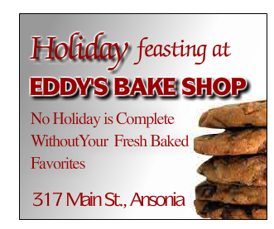  NEW  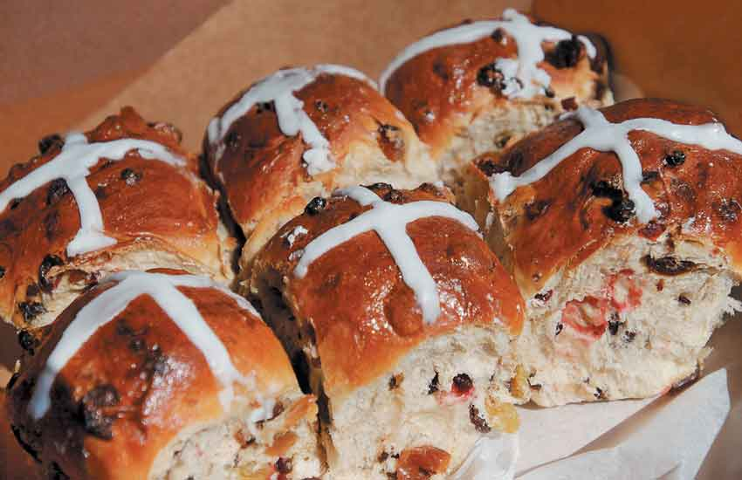  Add some small “Shamrocks”  Change theme color to Green  Leave Copy the same  Include pictures of Hot cross buns and/or Zeppole |  | Rotate images of the following and list names:  Paczki, St. Joseph Zeppole, Hot Cross Buns, Irish Soda Bread, Shamrock Cookies  “The best rye bread in the valley” |  | Use screen 2 of previous ad  Include “Place your order today”
Additional instructions? (specific colors, fonts, etc.)
This customer doesn’t have a logo or a website. I put in copy from the ad they had, but feel free to put the copy in any order you feel works better with the graphics.

Screen 2
  - Rotate images of the following and list names:
    - Paczki, St. Joseph Zeppole, Hot Cross Buns, Irish Soda Bread, Shamrock Cookies
    - “The best rye bread in the valley”
- Screen 3
  - Use screen 2 of previous ad
  - Include “Place your order today”



