Your Name: | Donna young | Advertiser Name: | New Canaan Wine Merchants
Your Email: | dyoung@bcnnew.com | Advertiser url: | www.newcanaanwine.com
Hearst Property: | CMG | Click thru url:
Date: | 1/12/10 | Ad size: | billboard
Use these boxes to describe or roughly layout your ad. Consider image, required copy, animation, call to action, required url, etc. [You can specify not to change anything or allow designer creative freedom.]
For static (jpg or gif) requests, just use the first frame.
300x250 format
Frame 1 |  | Frame 2 |  | Frame 3
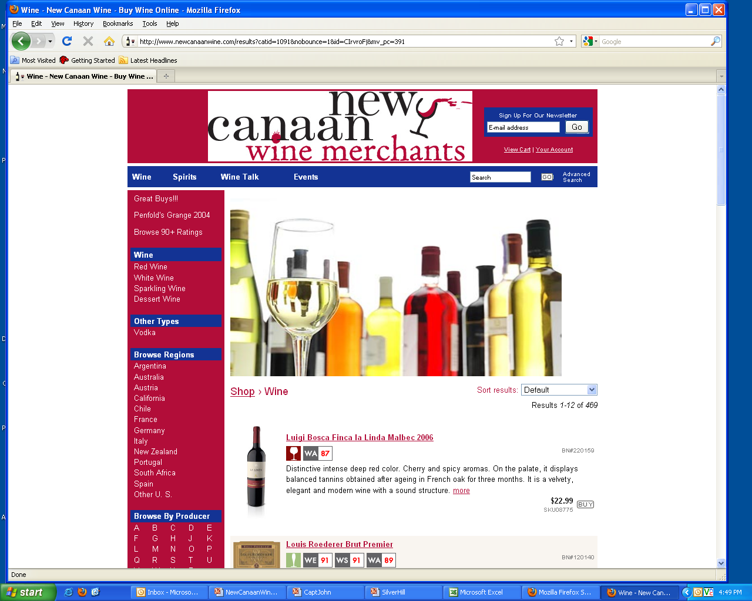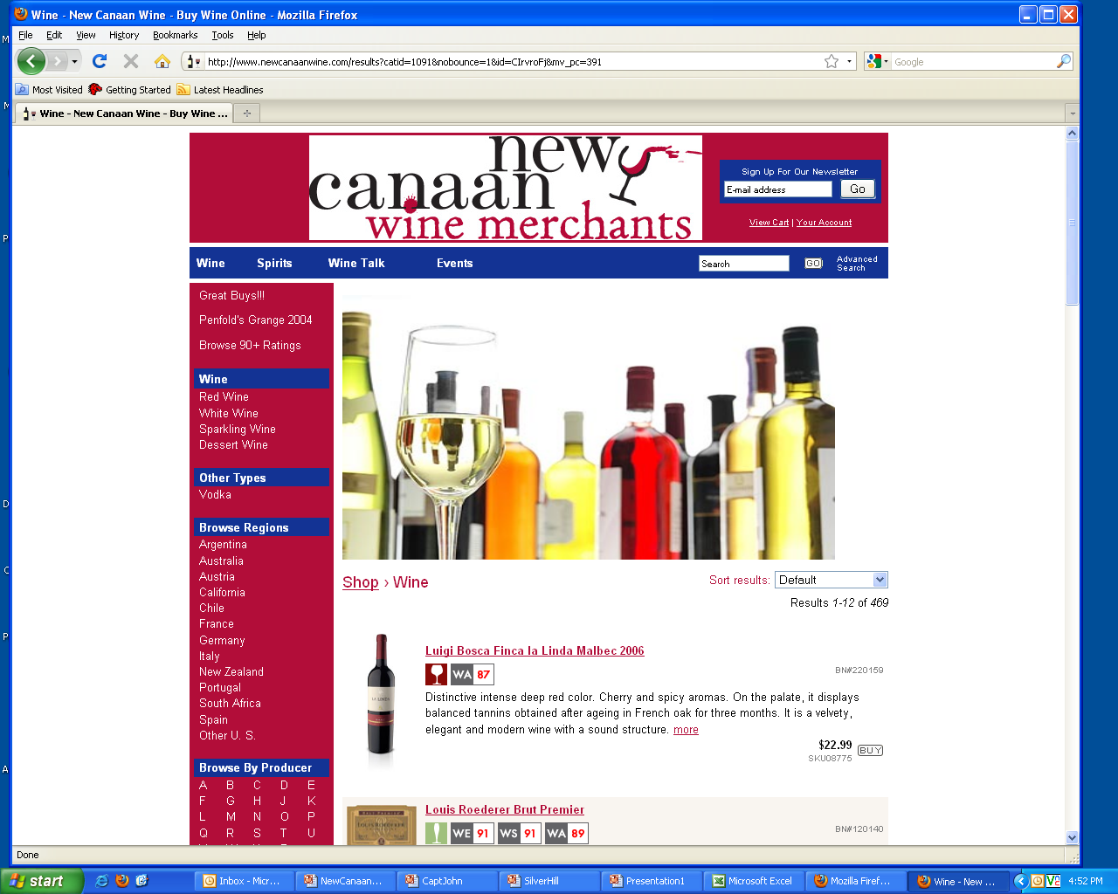 |  |  |  | Sign up today!  WINES of SPAIN  Classes  Jan. 12, 19 & 26th.  Click here.
Additional instructions? (specific colors, fonts, etc.)
Please create a spec ad for this store, need to have it animated and to feature the Wine classes that they have. Would like to get back by Thursday if at all possible. Thanks!

