
Thunder Ridge Ski Area

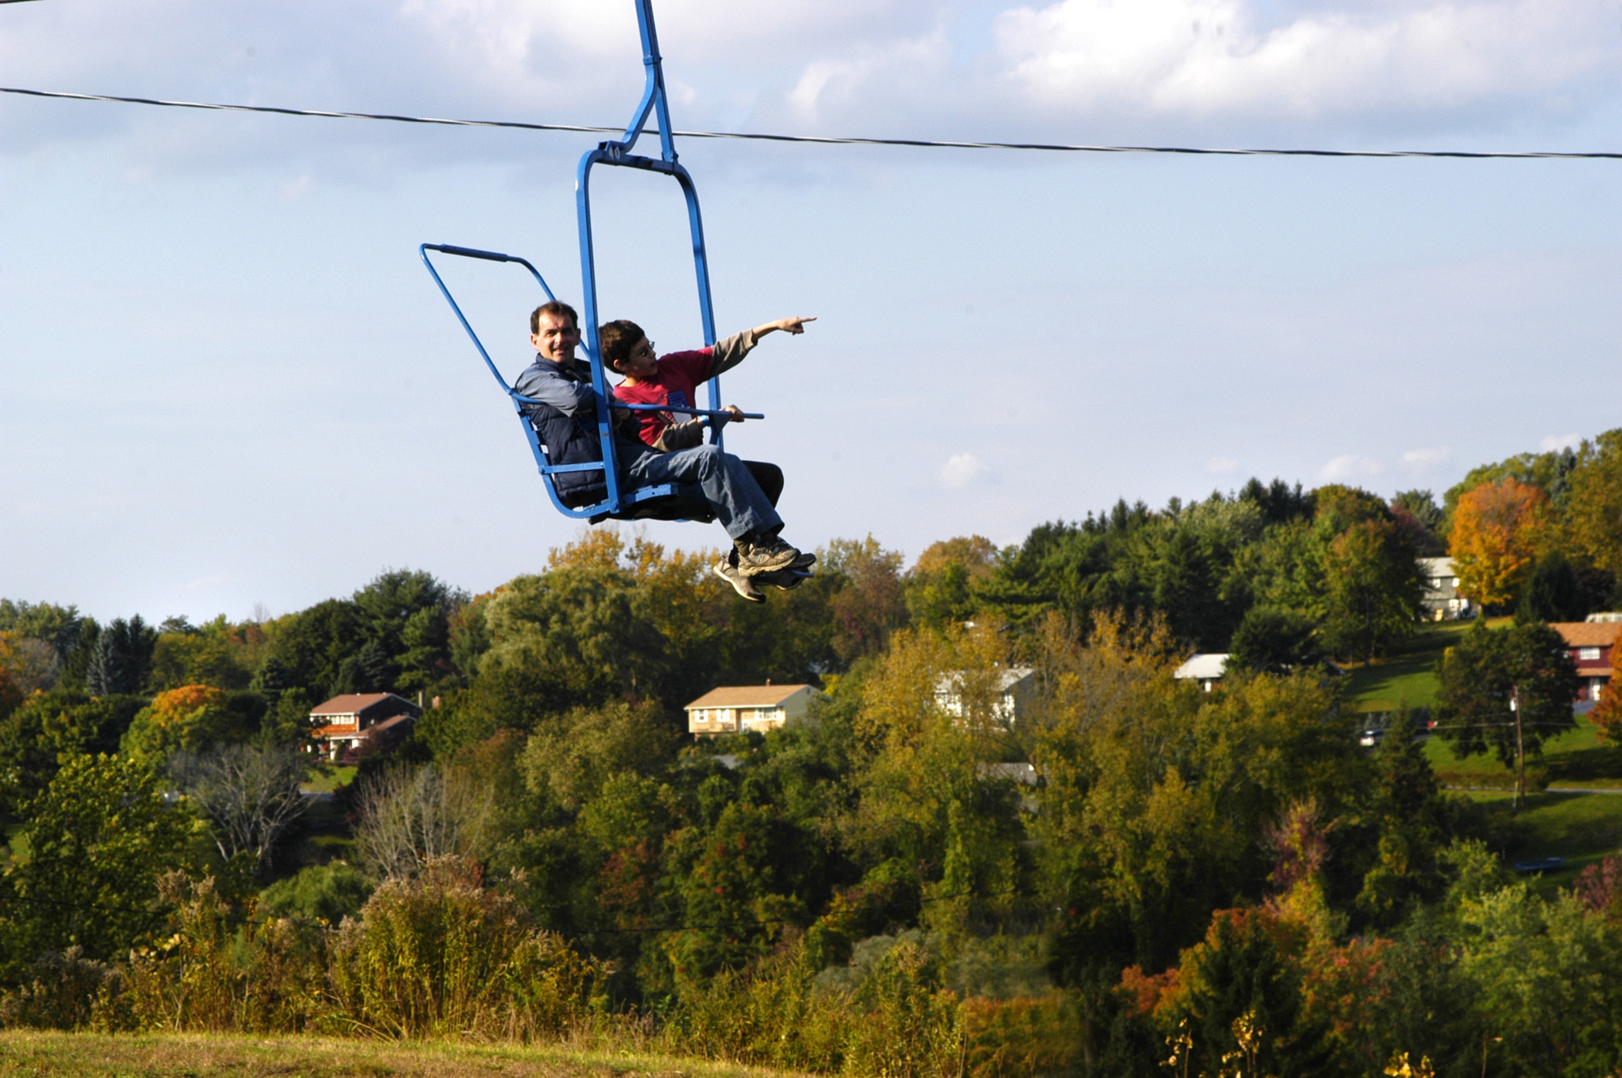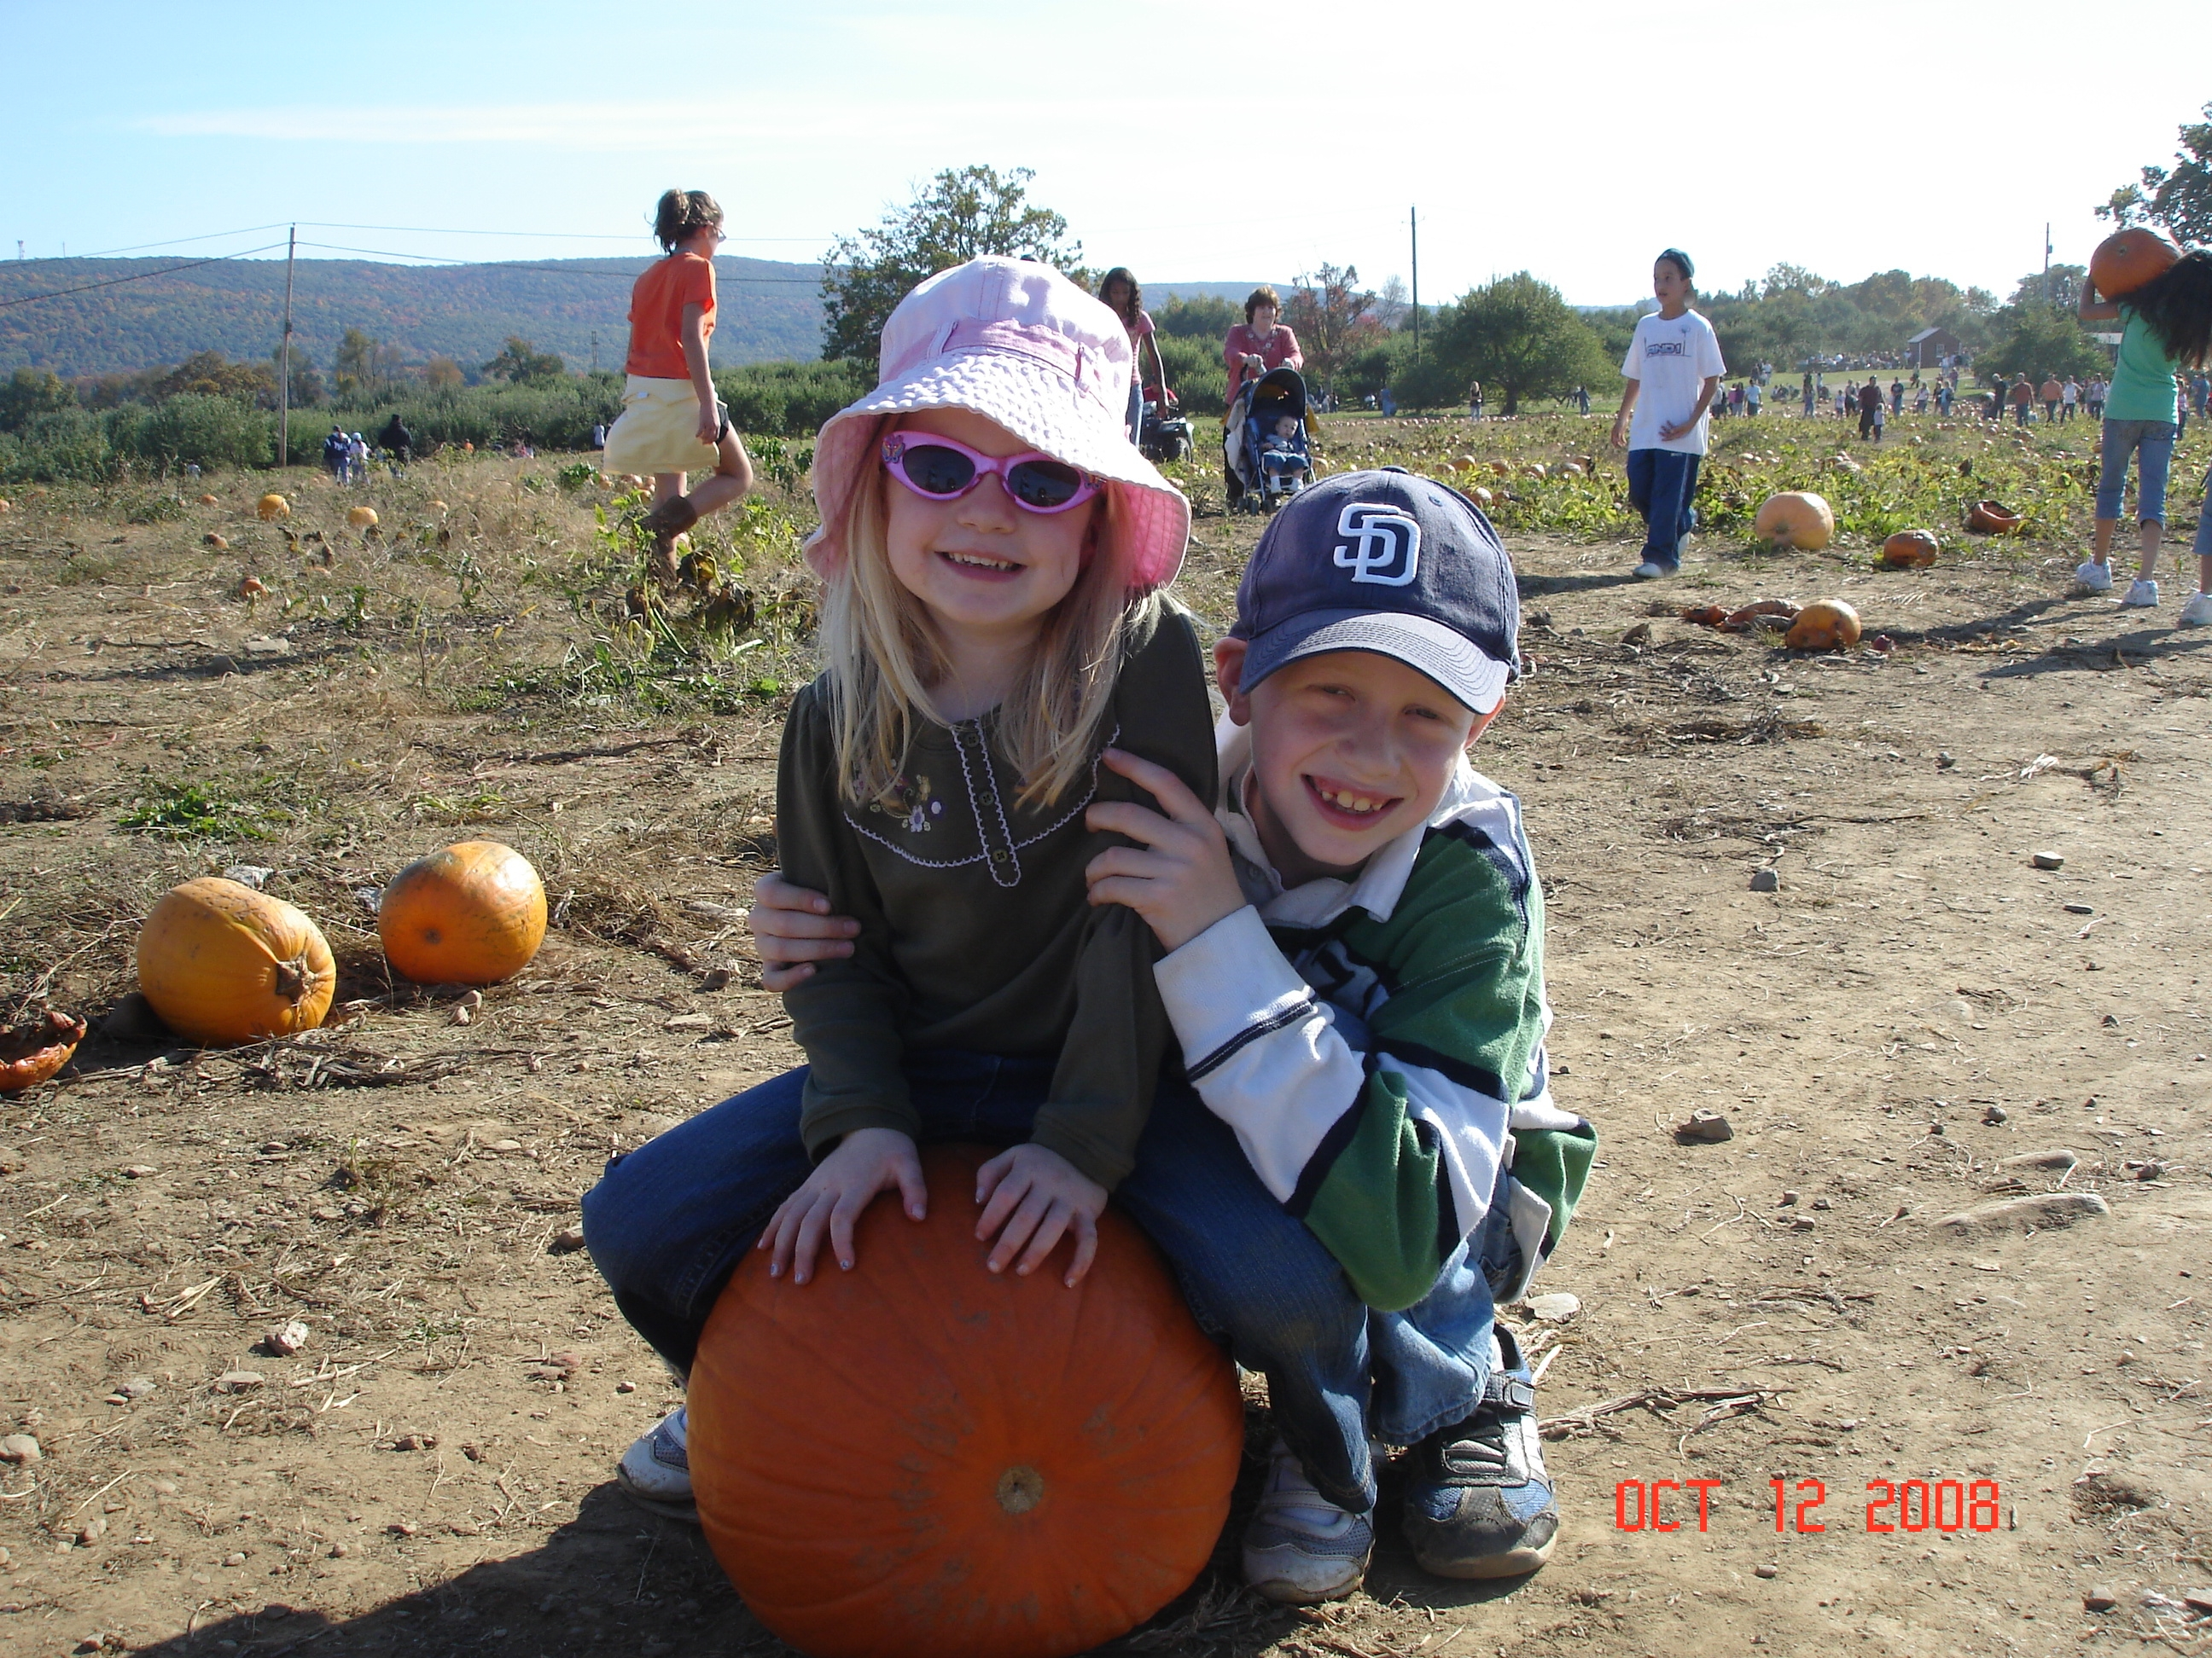

Saturday, Sundays & Columbus Day
Noon – 4 PM
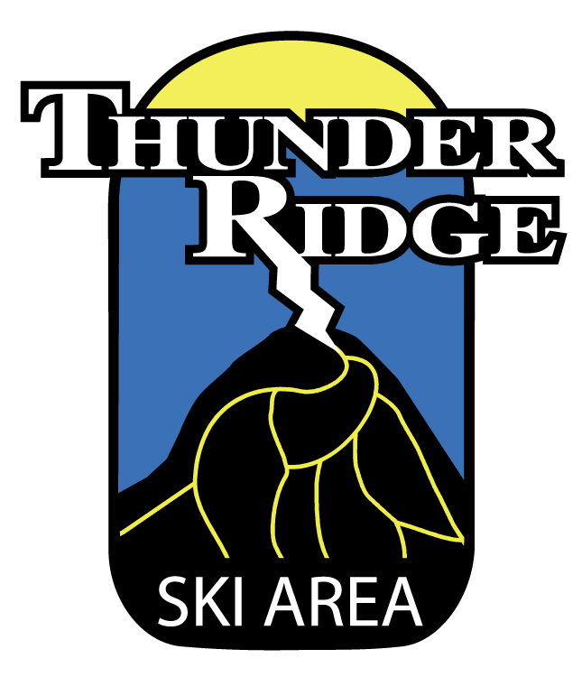
Scenic Chairlift Rides, Hayrides, Mazes, Farm Animals & Pumpkin Picking!!

845-878-4100
www.thunderridgeski.com

