Be Fit. Be Healthy. Belong
Founded in 1923, the Westport Weston Family Y is a charitable, nonprofit membership organization that welcomes people of all ages, races, religions, abilities and financial circumstances.
The Family Y's mission is to develop youth, promote healthy living and foster a sense of social responsibility. Our current membership of 5,000 represents nearly 15 percent of our community and 25 percent of all local youth.
FREE 3-WEEK MEMBERSHIP TRIAL OFFER
Stop in by March 31, 2014, to activate your free 3-week membership at the Family Y. This special offer includes unlimited use of our Y facility at 59 Post Road East in downtown Westport.
What's more, join as an Adult or Family Member by March 31, and we'll waive our usual $50 joiner fee. Plus, you'll also receive FREE guest passes (10 for Family, 5 for Adult) to use for friends and family.
Don't delay, activate your free 3-week membership today. Simply stop by the Y's Membership Services Desk at our Church Lane entrance or call 203-226-8981.
We are also making a special time-limited offer to our Members: Share the Y with someone you know! Receive one FREE month for each new Y member that you bring in between now and March 31.
2014 Membership Application
Join Online
MEMBERSHIP BENEFITS:
Membership at the Westport Weston Family Y entitles you to enjoy our facility at 59 Post Road East. Our Family Y offers something for everyone: families, new and expecting moms, youth and seniors. Enjoy all these amenities, and more:
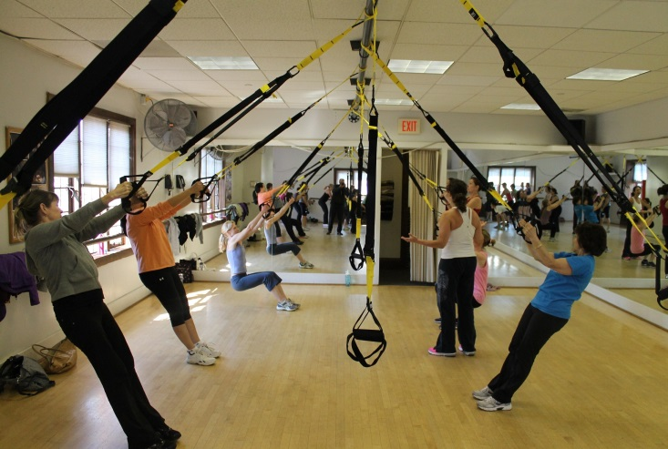
- 25-yard lap pool, shallow pool for aqua fitness, warm-water pool for therapy, lessons and family fun

- Multi-purpose gymnasium

- Three fitness studios and spinning room

- Two-level Wellness Center

- Gymnastic Center, for toddlers to teens

- More than 70 group-fitness classes each week
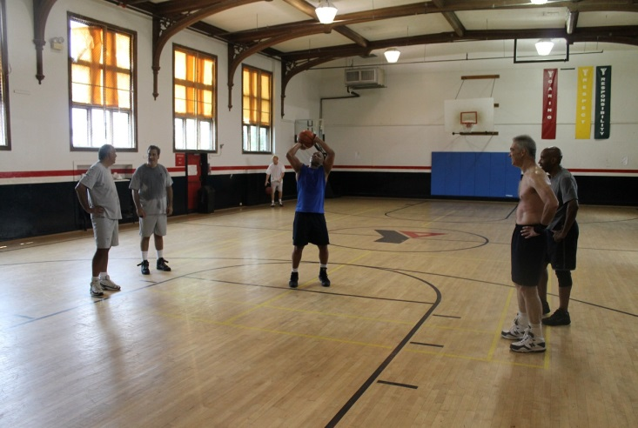
- Youth & Adult Basketball

- Parent-child classes

- Men's and Women's; Boys and Girls locker rooms

- Racquetball, handball and squash courts

- Whirlpool

- Saunas

- Free towels

- Free babysitting - click for details

